MTRE4002 Feedback Control Laboratory

**Lab #0 Modeling Dynamics System Using**

**MATLAB and Simulink**

By Amir Ali Amiri Moghadam, Ph.D.

College of Engineering

Kennesaw State University

Marietta, GA

**Objective**

In this lab, students are required to analyze the response of a dynamic system using the MATLAB M code and Simulink.

**Background knowledge**

Consider a simple RC circuits, where R is the resistor and C is the capacitor. The governing differential equation can be obtained as follow:



**Fig. 1:** Diagram of the RC circuit.

**Example_1:** Solve this equation for a step input of 0.1 V and consider the resistance to be 30 Ω and the capacitance to be 0.0237 F. Also use Euler method (+f(t)).

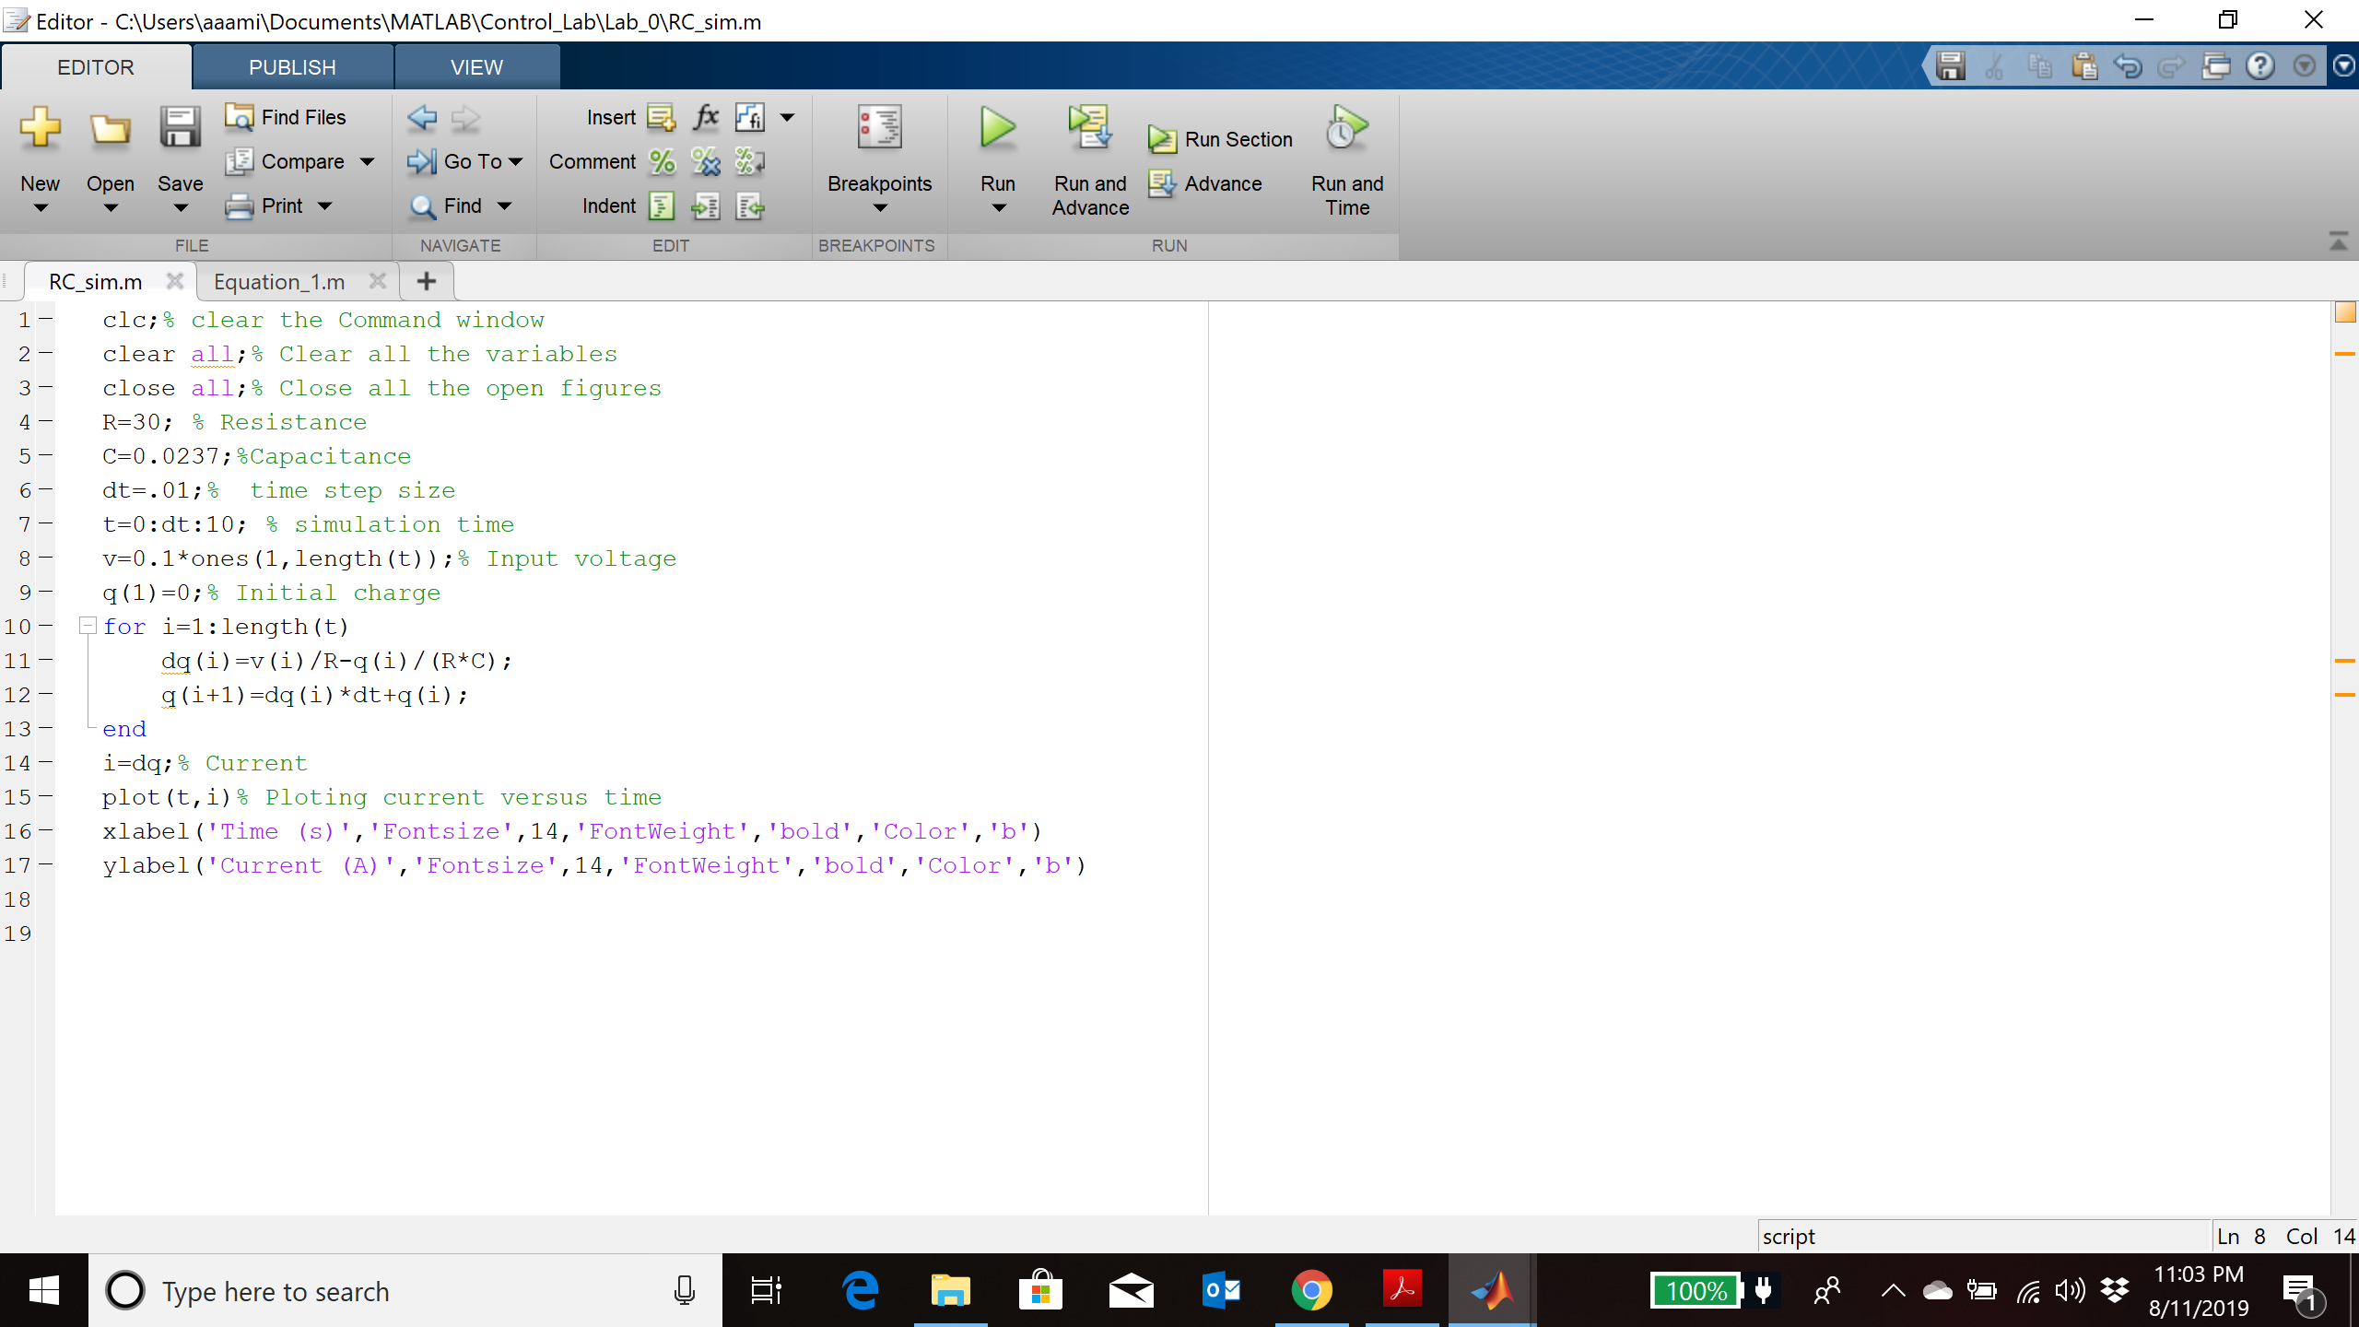



**Fig. 2:** Diagram of the RC circuit.

**Example_2:** Model the RC circuit with Simulink. Open a Simulink model.

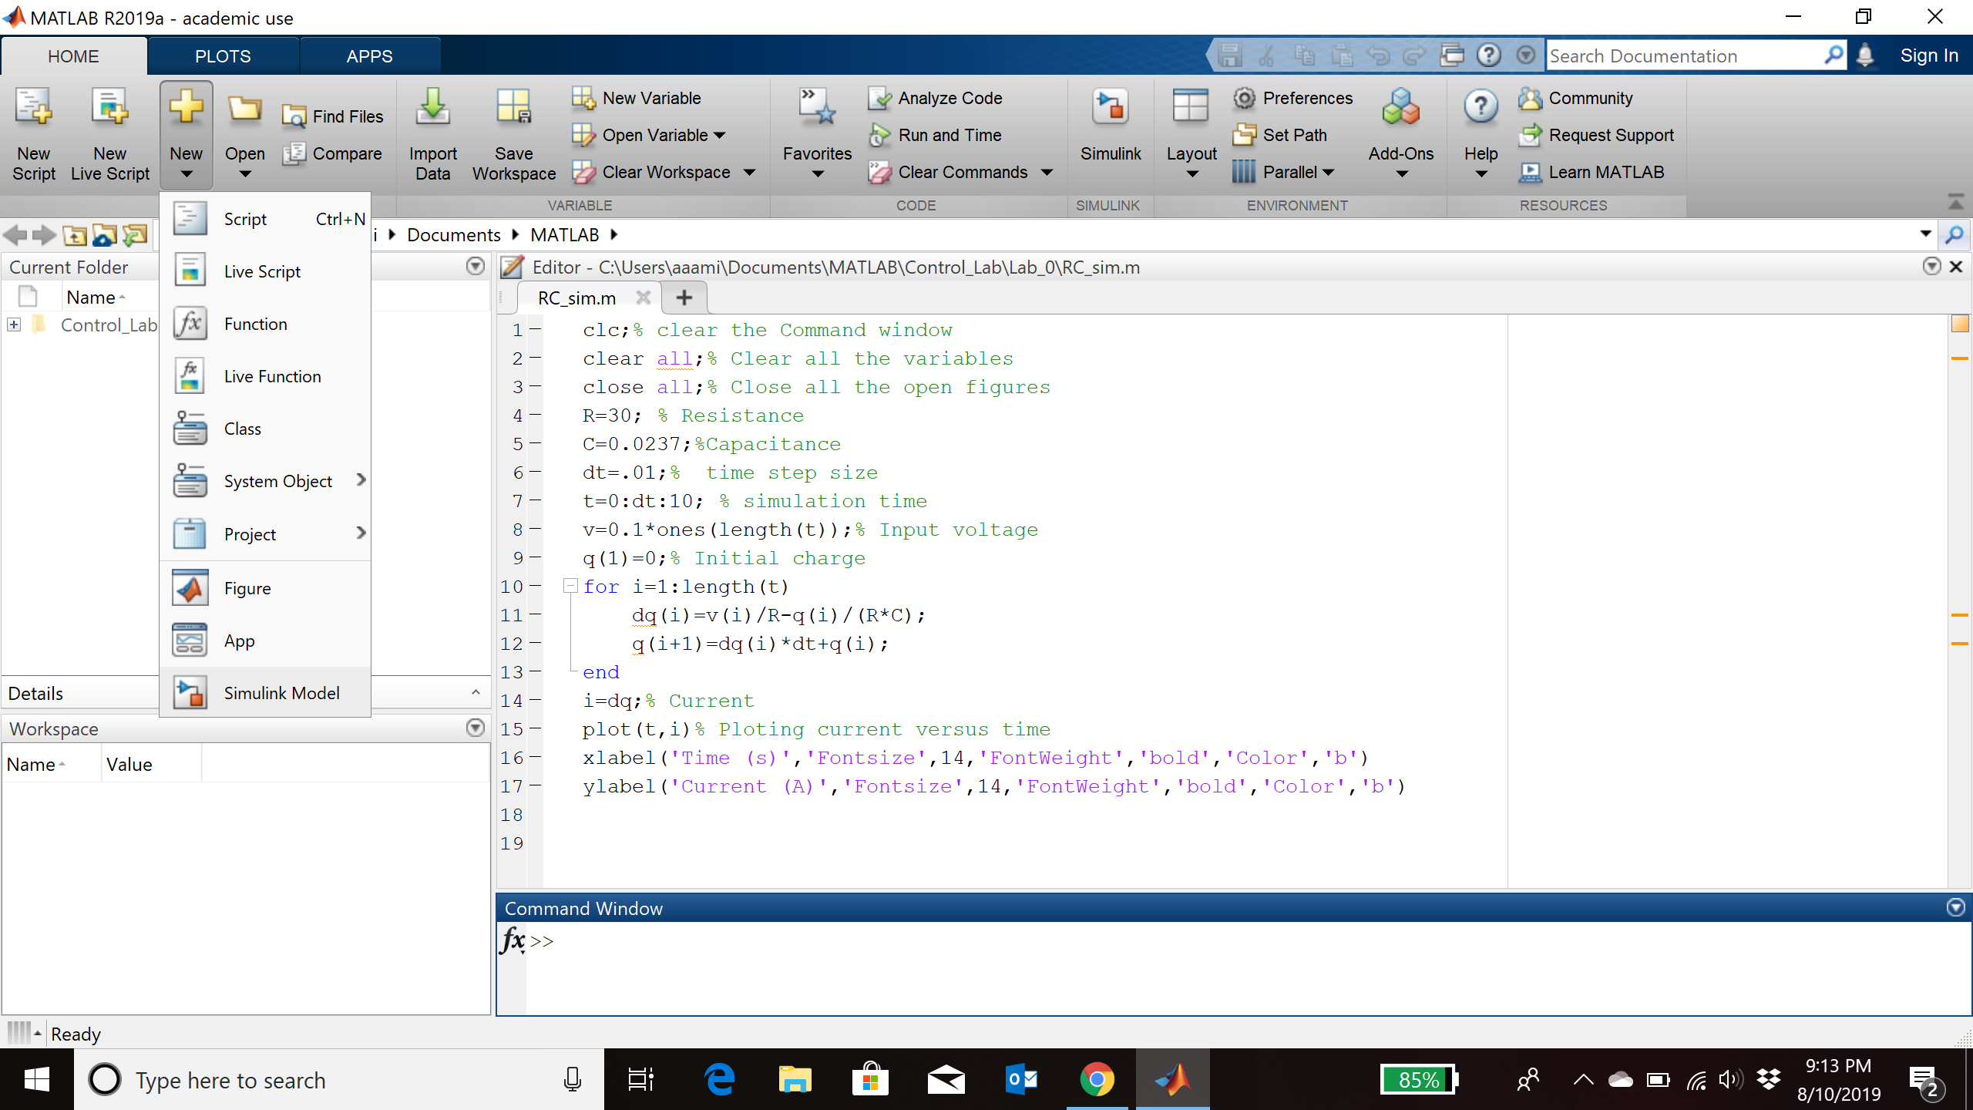

From the library under Commonly used blocks add the following items to the model.

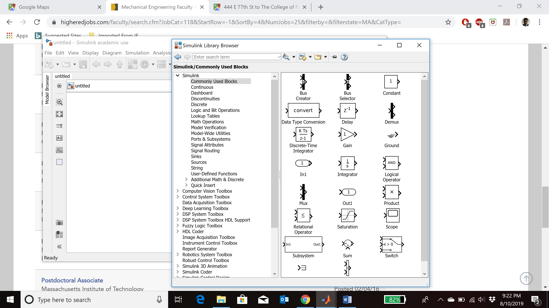

From library and under sources add the step function to the model.

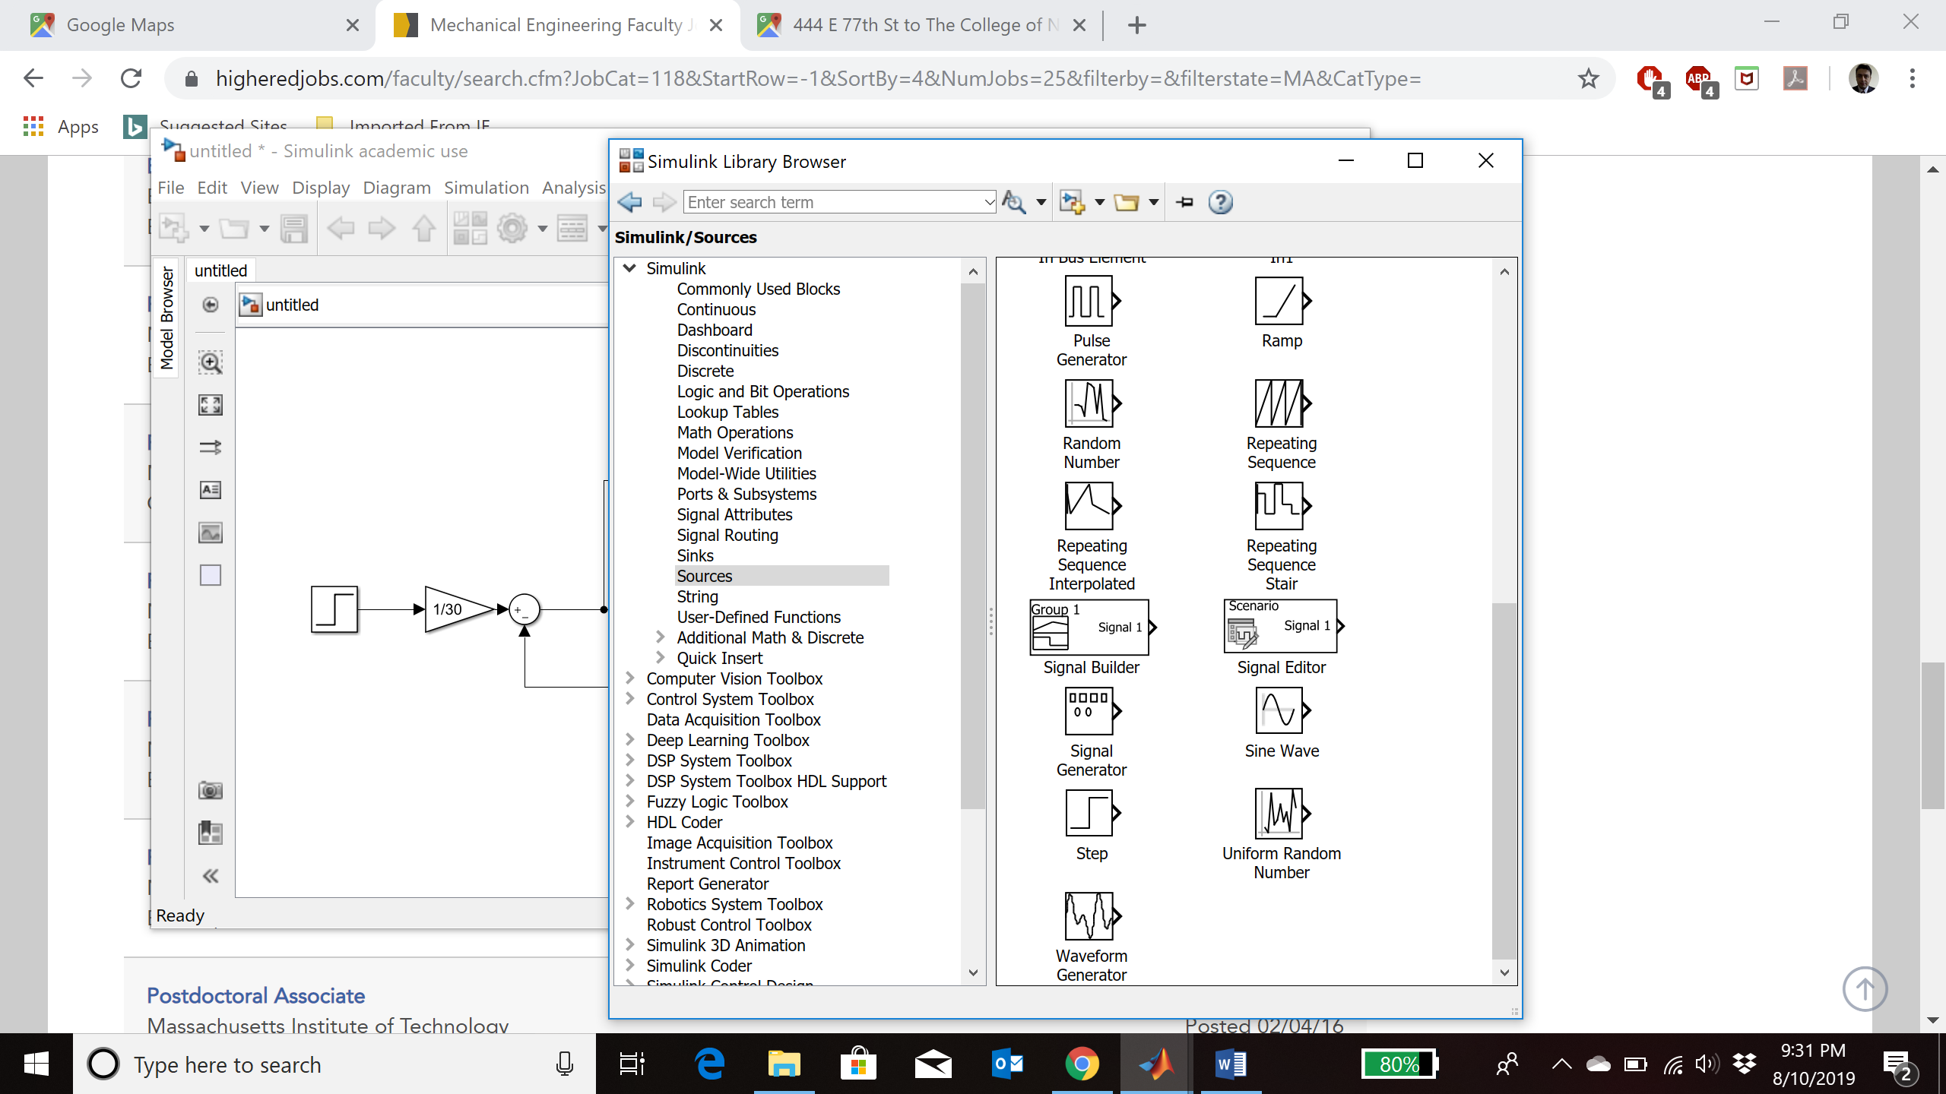

Connect the blocks as follow:

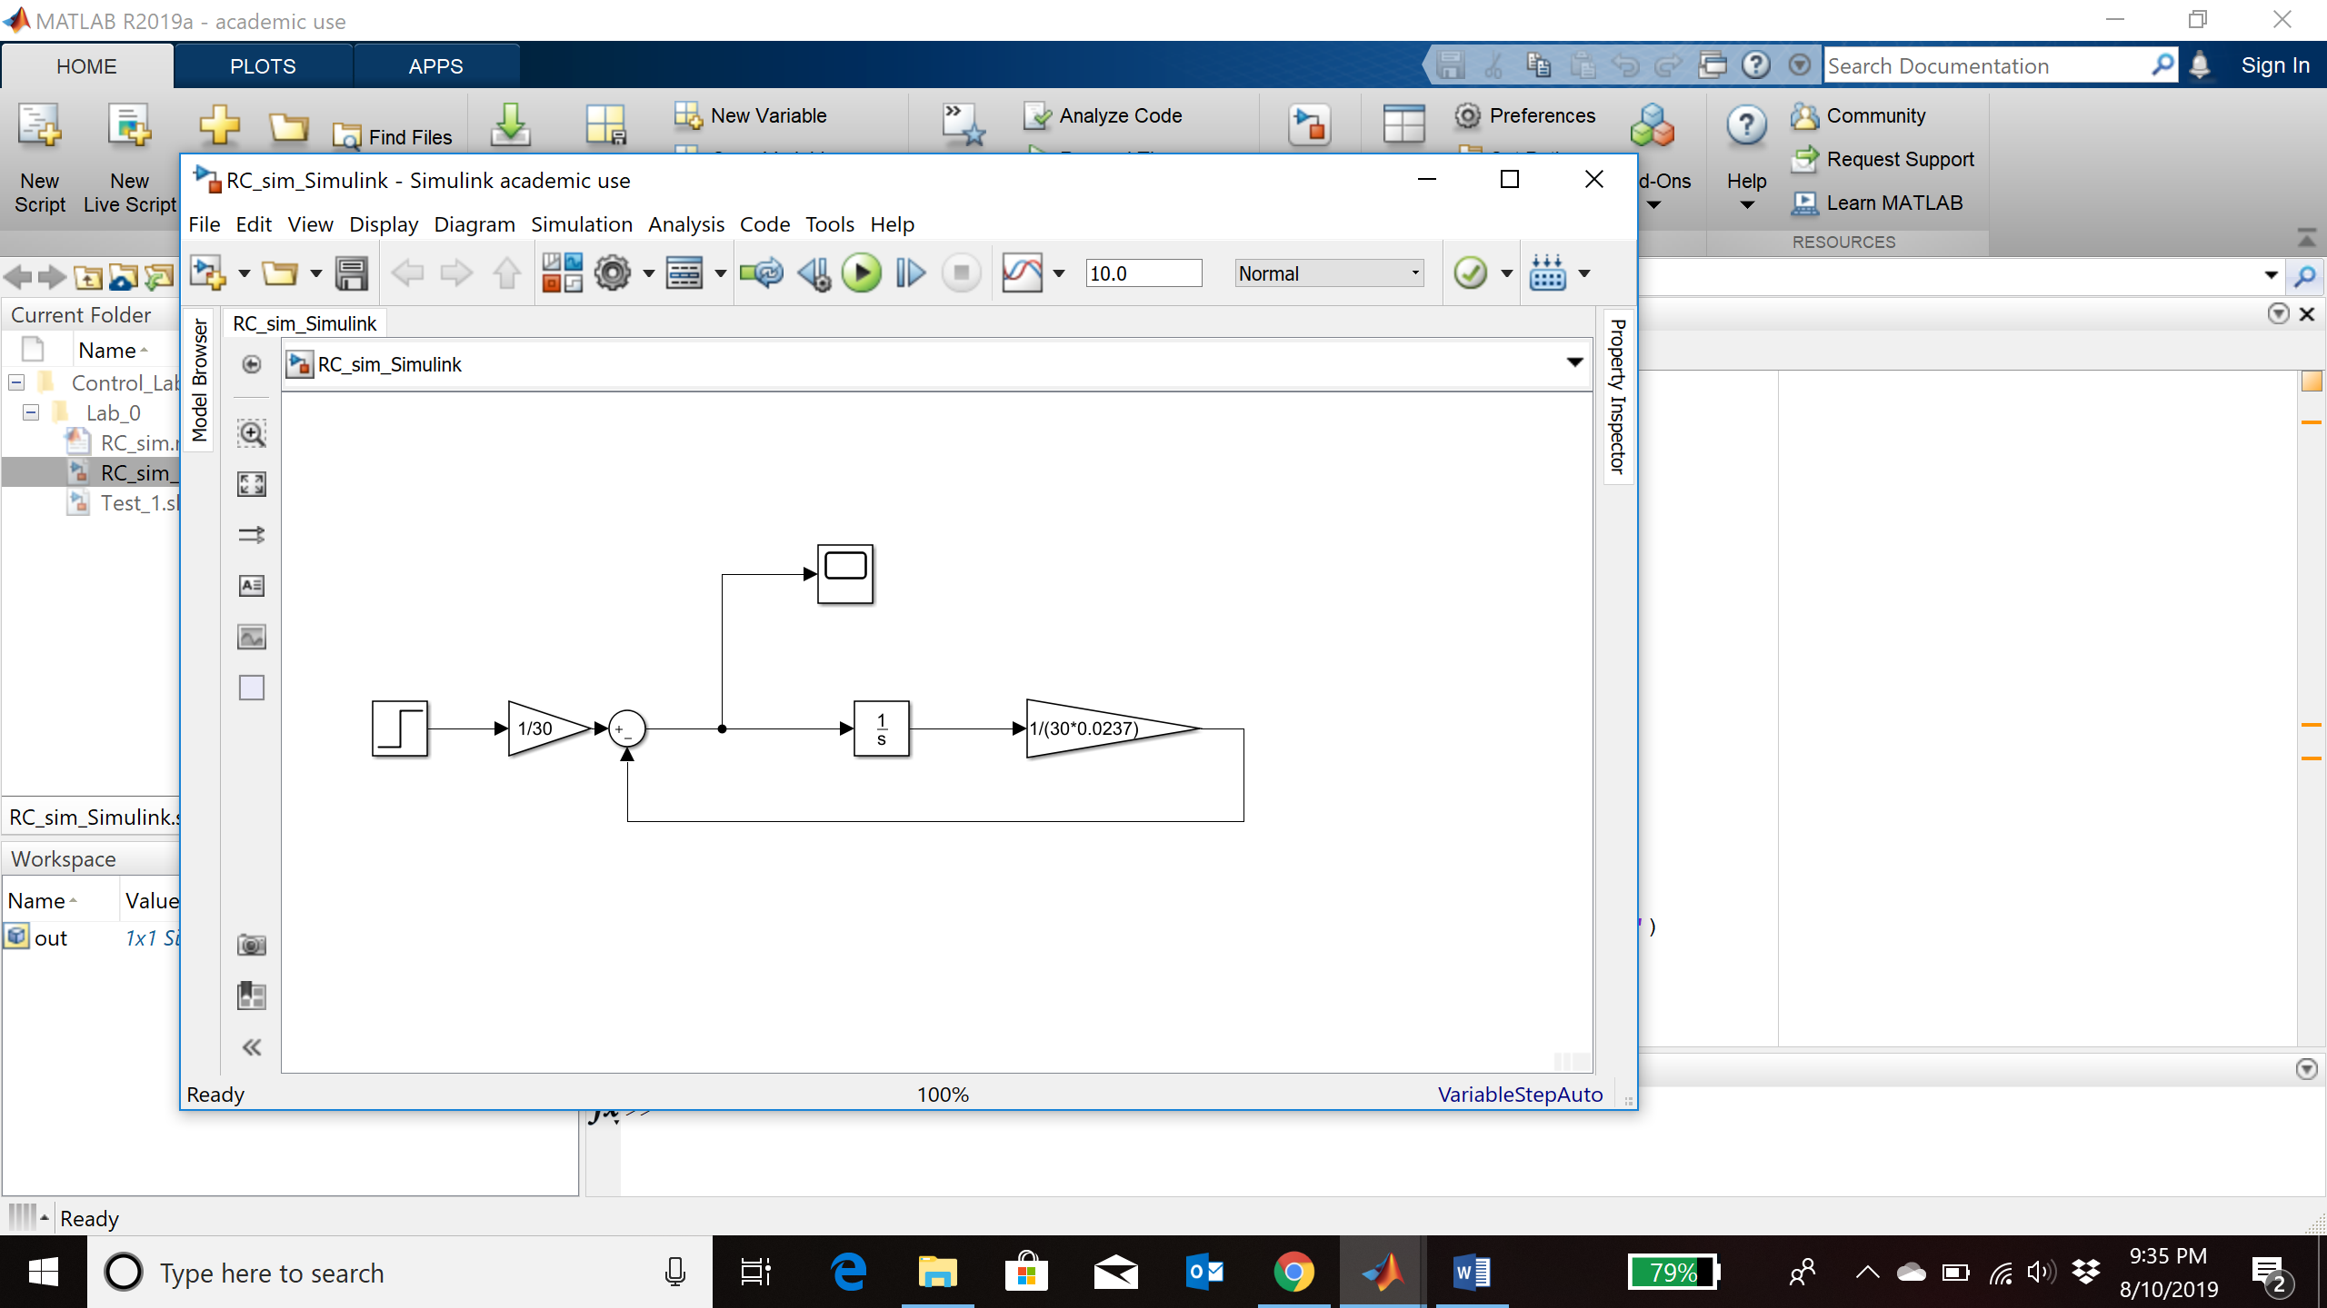

Change the values of the gains to 1/30 and 1/(30*0.0237), and change the value of the step function to 0.1. Now run the simulations and the observe the value of the current through the scope.

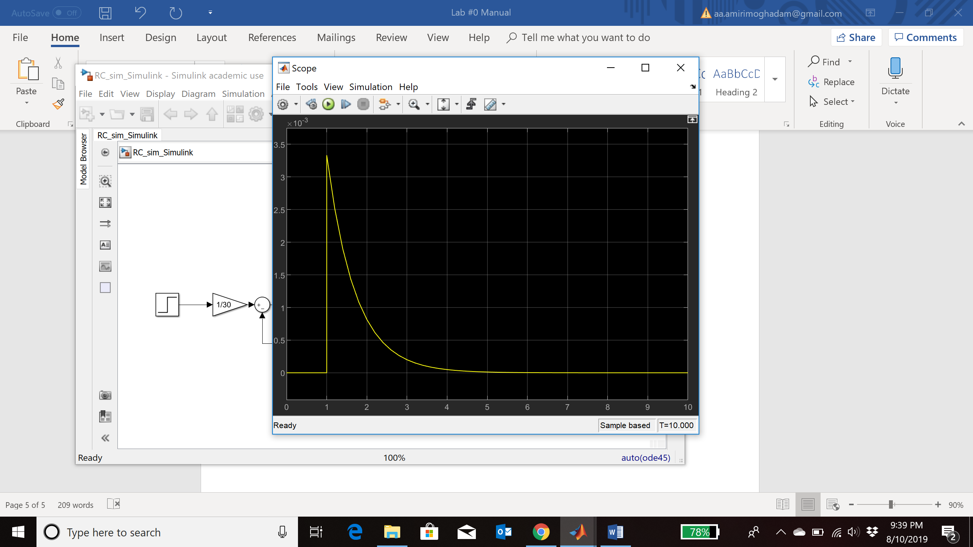

**Lab report requirement**

**Question_1:** Simulate the current response of the above RC circuit to a input voltage of v(t)=.1*sin(2πt) using M file. (Time step size =0.01)

**Question_2:** Simulate the current response of the above RC circuit to a input voltage of v(t)=.1*sin(2πt) using Simulink.

**Question_3:** Simulate the response of the following dynamic system using the M file. Consider zero initial condition and Time step size =0.01. Simulate the response for 10 seconds.

Where u(t) is the step function. To apply the Euler method, use the following equations:

**Question_4:** Considering the analytical solution to the equation is:

calculate the maximum error (y_analytical-y_numerical) for period of 10 second and time step sizes of 0.5 s, 0.1s and 0.01s. For each case plot the analytical and numerical solutions in a single figure using the “hold on” command. Finally, plot the error signal for each case.

**Question_5:** Repeat question_3 and 4 for input sine wave of sin(2πt) and consider the analytical solution to be:

**Question_6:** Simulate the response of the above-mentioned dynamic system using the Simulink for both step input and sine wave of sin(2πt). You do not need to change the time step size.

**Please note:**

* The lab report should be an official technical report, including the information such as experiment objectives, background information. Include the problems statement and add figure caption and Number!
* Each student needs to submit his/her independent lab report.
* You need to submit the MATLAB source codes, its running result and the output figures.
* You need to submit the Simulink model circuit and the response curves.